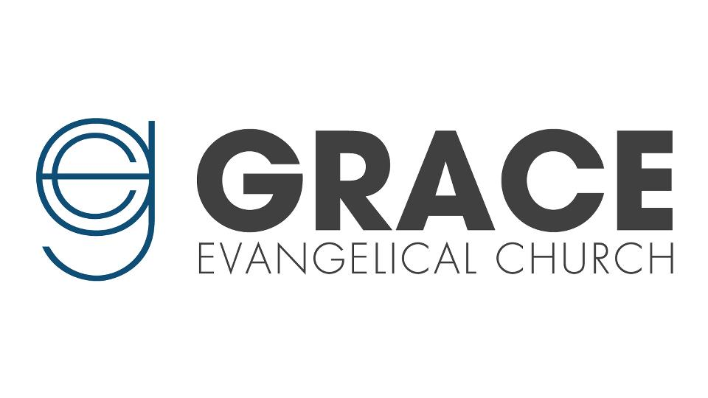

Worship Ministry Director (WMD)
Job Description
Part-Time
Grace Evangelical Church of Elgin is a non-denominational church in the western suburbs of Chicago. We are looking to hire a person for the part-time position of Worship Ministry Director (WMD) who is passionate about leading people both in private and corporate worship. This person must embrace our purpose which is to glorify God and serve our community. They must be able to fully support our doctrinal statement. The WMD must also fit into the GEC staff and church culture & joyfully uphold our staff's core leadership values. The WMD’s primary responsibility will be to develop and lead a Jesus-centered worship culture at the GEC while working closely with our Lead Pastor to coordinate our weekend services.

The WMD’s Calling, Gifts, & Skill Set
Music: the WMD must be a gifted worship leader, musician, proficient in music theory, and competent vocally and instrumentally (guitar and/or piano)
Leadership: Have a desire for leading and managing volunteers and teams, recruiting volunteers, gradually releasing creative team members, and leading others to joyfully engage in worship
Technology: A functional knowledge with ProPresenter, Planning Center, audio, and video software is desired.
Discipleship: the WMD must be passionate about making biblical disciples, especially through worship ministry and music
Communication: the WMD must be a gifted communicator, comfortable in front of people, able to helpfully teach and communicate the Bible within and around worship

Future Ministry Potential (beyond Worship Ministry)
This is an excellent opportunity! If the WMD has a desire, passion, and giftedness for expanded local church ministry, especially in the area of Youth Ministry, GEC will consider this opportunity.

Weekly Schedule (6-7 hours)

WMD Compensation
A $3,900 annual compensation. However, this is somewhat negotiable and would be adjusted, especially if additional ministry responsibility is taken on.

